**NAGIOS Troubleshooting checks**

Nagios API check :

Login to the server, then try to connect Nagios API

API: <https://health.1cloudhub.com/nrdp/>

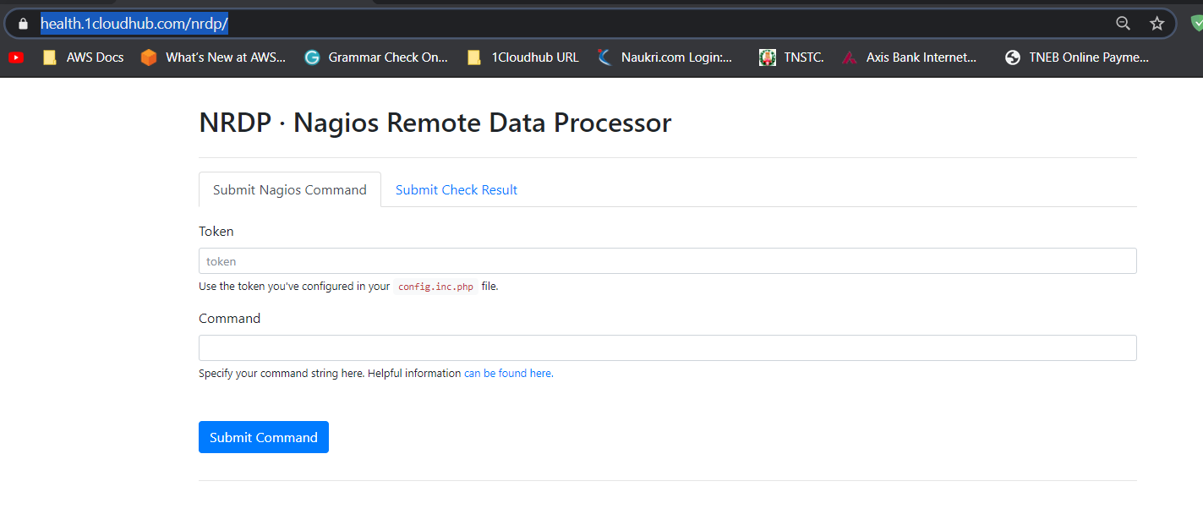

Script check: NRDS.vbs

Command: **cscript nrds.vbs**

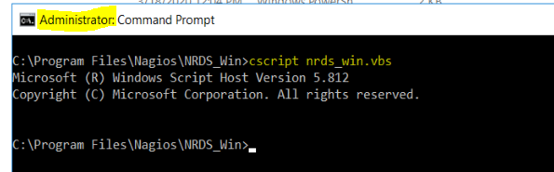

**Check the logs**

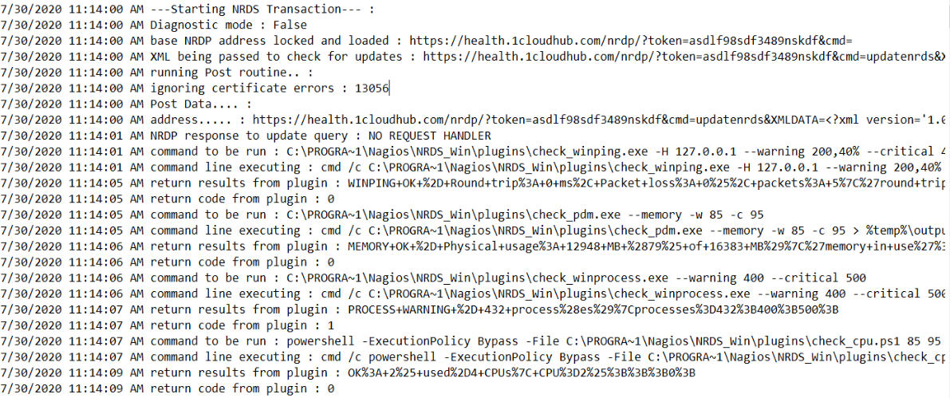

**Each plugin checks:**

Go to the Nagios plugin folder and check each plugin used command as mentioned by config files

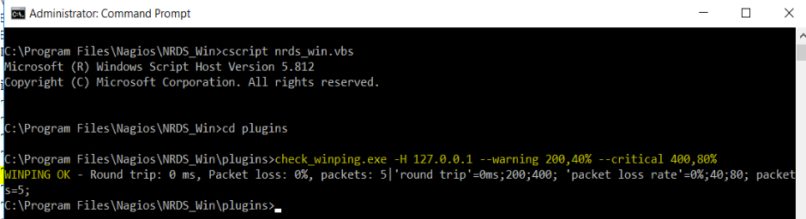

**Task scheduler checks**

**Please check task properties and Task history**

